Hey Neighbour,

Do you feel as though your property has been on the market a while?

Are you looking to be sold ASAP and still want a reasonable price?

Do you need another alternative, rather than price reduction?

I’ve got exciting news: there’s now an agent in your area certified to use Openn Negotiation; an established online auction process that is proven to deliver better results in less time.

Why use Openn Negotiation?
- Potential to sell your property in 3-4 weeks
- Secure contracted, competitive buyers approved by you
- Achieve your best price by allowing buyers to continually improve their bids

Buyers expect to pay less for properties the longer they sit on the market.

This process means fewer days on the market and the best price achieved for you.

So try something new, for just $550 you could join hundreds of sellers who have achieved a price they can smile about.

P.S. Openn Negotiation listings consistently receive interest from buyers located interstate and sometimes even overseas! Why limit yourself to local buyers when you could cast a wider net?

What next?
If you’re wanting to look at Openn Negotiation as another option or would like to observe a real Openn Negotiation online, get in touch on XXXXX XXXXXX or email me at XXXXX@XXXXXXX.
Yours sincerely,
[NAME]
[AGENCY]
[EMAIL]
[CONTACT NUMBER]

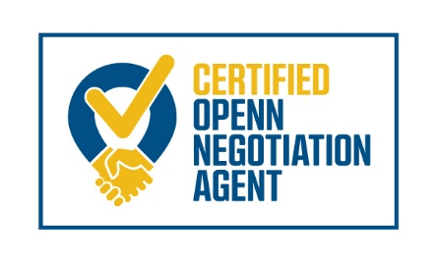

AGENT LOGO

